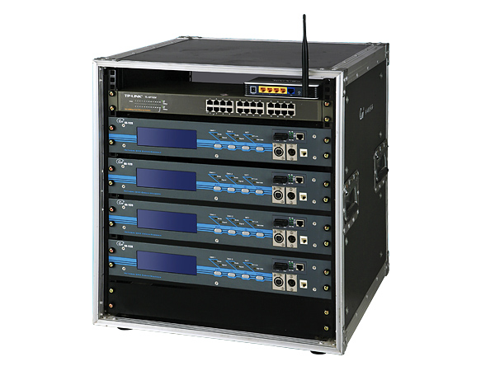

CEE ON-4248R

Function & Performance:
●By an optical fiber/wireless 8 DMX channel node, a 24 channel network concentrator, as well as the UPS power source and the special-purpose 19 English rack is composed. 
●May provide 4 pair of optical fiber connections, 24 RJ45 mesh wire connection, 8 DMX channel input/output and 1 channel wireless network turning on. 
● Comes from the control room control network signal through a pair of optical fiber turning on, simultaneously through another 2 pair of fiber optic transmission other stage vice-network light workstation. 
● The workstation plays the central key position role in the stage light control network, 1 channel wireless network correspondence has provided one with the control room network light workstation reserve correspondence pipeline. When the host fiber optic transmission breaks down accidentally, may start this wireless reserve correspondence pipeline in the instantaneous seamless earth, guaranteed the master control signal is safe. 
●Conforms to following agreement: DMX-512(1990) standard agreement, the IEE802.3 ether network protocol, the IEEE801.11b/g wireless ether network protocol, may the software promote “ACN” the American ESTA Organization advanced network control standard agreement to discuss.

Techmical Parameter：
●4 pairs (multi-molds) optical fiber TCP/IP network connection;
●8 channel DMX512 signal input, output;
●24 channel RJ45 TCP/IP network connection;
●1 channel wireless TCP/IP network connection;
●Mesh wire maximum transmitting range: 100M;
● Wireless maximum transmitting range: 300M;
● Optical fiber maximum transmitting range: 3000M.
● Ambient temperature: - 10℃~+35℃
●Relative humidity: 20%~90%
●Working conditions: Ventilates good, not massive mist and dust.

Order information:
Module | Description | Size
ON-4248R | Lighting network station

