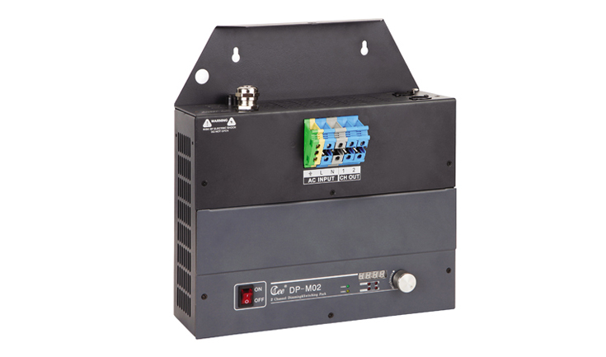

CEE DP-M02

Function and performance:
Two channels 0-100% linear dimming,every channel's maximum current is 20A(4KW,220V)
Power supply:AC220v±10%，50Hz±2%，Single-phase to three-phase power input five line
Standard DMX512 signal control (1990)
Independent air switch insurance every all the way，with over-current automatic shuting off protection function.
Using convection cooling heat,overtemperature protection system, to ensure product sustainable operation.
Selects imported high quality silicon controlled rectifier and the maximum isolation voltage is 7500 v.
Using high-performance choke coil suppress harmonic componenteffectively reduces electromagnetic noise.
High precision through zero detection technology,each channel output consistency is good.
Possible being set up manually through the output which can realize emergency output when signal is lost.
Using wall-hung type installation,easy to maintain.

